# CS 255 System Design Document Template

This template lays out all the different sections that you need to complete for Project Two. Each section has guidance to prompt your thinking. You will need to continually reference the interview transcript as you work to make sure that you are addressing your client’s needs. There is no required length for the final document. Instead the goal is to complete each section based on what your client’s needs are. Remove this note when you are finished, and replace all bracketed text with the relevant information.

## UML Diagrams

### UML Use Case Diagram

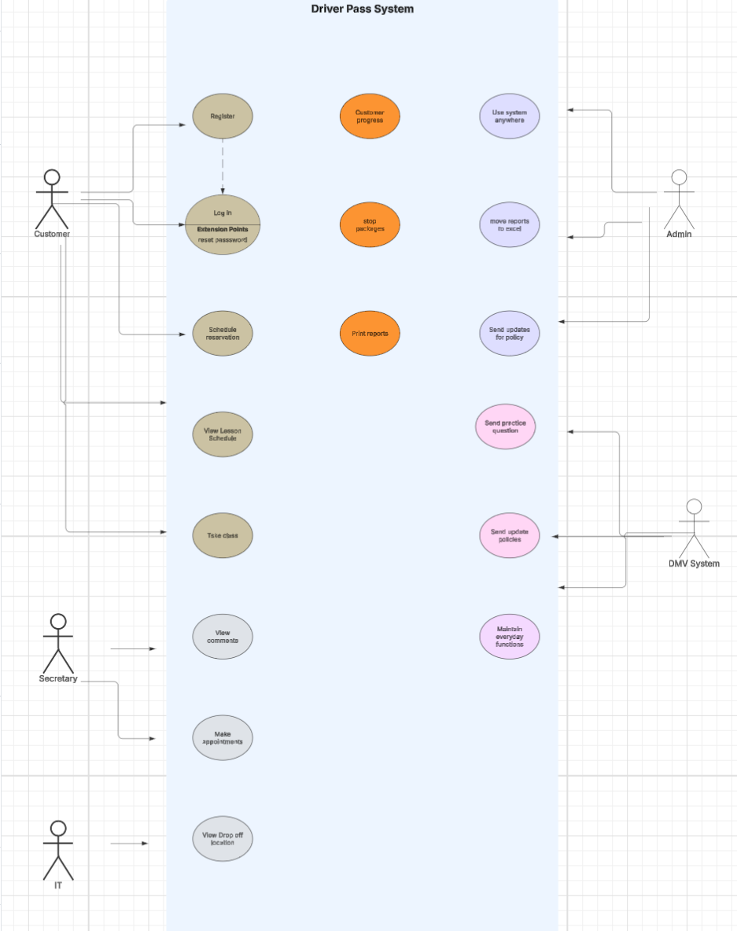

### UML Activity Diagrams

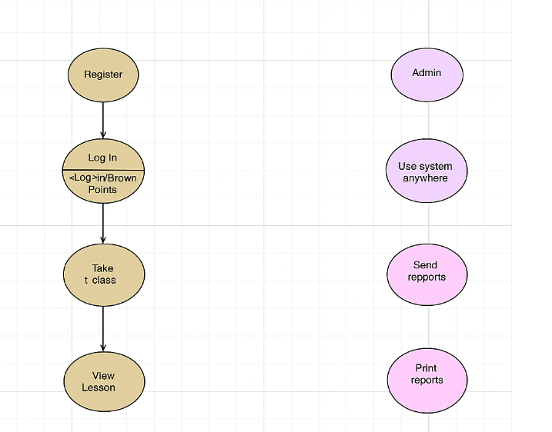

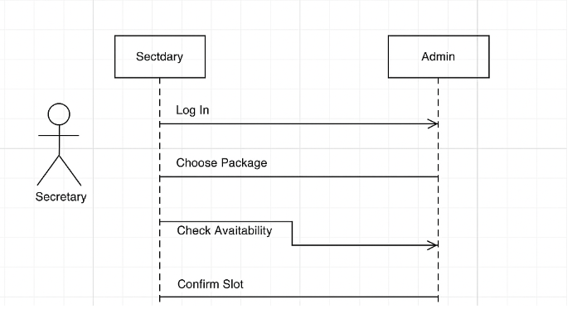

### UML Sequence Diagram

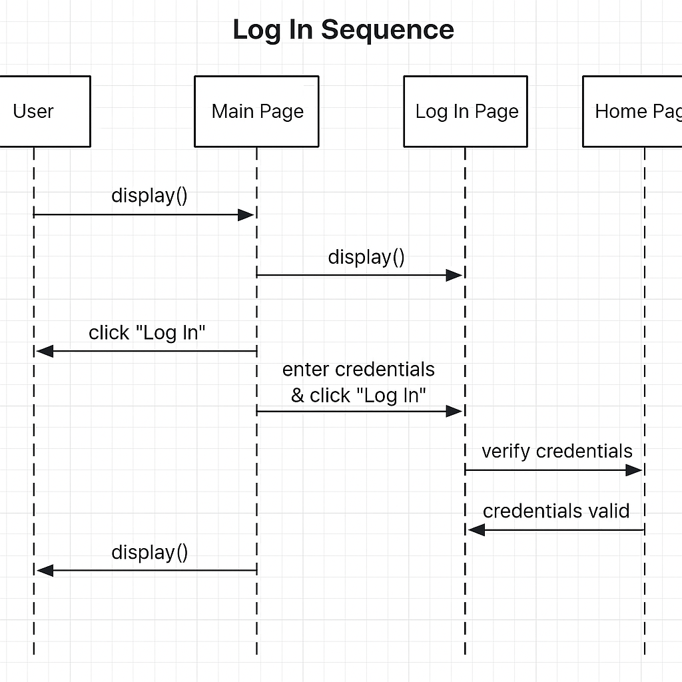

### UML Class Diagram

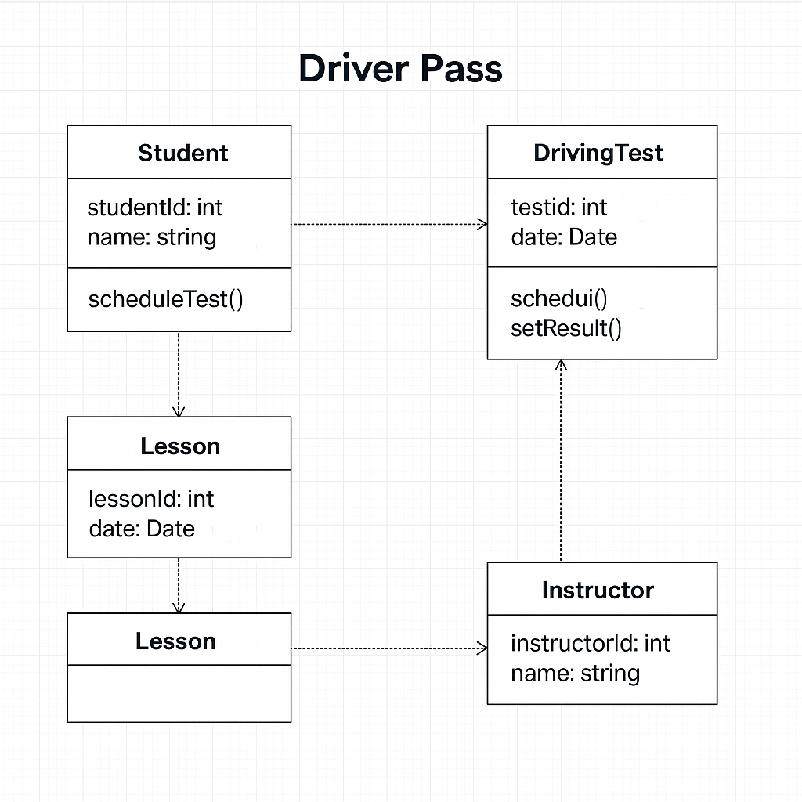

## Technical Requirements

To make the DriverPass system work the right way, we need some important tools and equipment.

**Hardware :**  
 We need a strong computer (called a server) that stores all the data, like lesson times and test results. It should have lots of memory (RAM) and space (storage). People using DriverPass can use phones, tablets, or computers to log in and use the system.

**Software :**  
 We’ll use a program to build the front of the website and another to run everything behind the scenes. We also need a database, which is like a digital notebook that remembers all the information.

**Tools :**  
 To build DriverPass, we use special computer programs where we write code, design diagrams, and keep all our work organized. These tools help the team work together and test the system to make sure it works right.

**Infrastructure :**  
 We’ll use a cloud service to run the website so it’s always available. We’ll also keep the website safe using internet security tools, like passwords and encrypted connections. We’ll back up the information often so nothing gets lost.

With these tools and systems, DriverPass will run smoothly and safely for all users.